**Unlocking Insights into the Global Air Transportation Network with Tableau**

1. INTRODUCTION

1.1 Overview

*Air Transportation is the transportation of passengers and goods via aircrafts.

*The Global Air Transportation market is expected to witness significant growth in the forecast period owing to the increasing air passenger traffic, growing number of airport expansion projects and rising demand for air freight service.

1.2 Purpose

Air Transport allows people from different countries to cross international boundaries and travel other countries for personal, business, medical and tourism purposes.

2. Problem Definition & Design Thinking

2.1 Empathy Map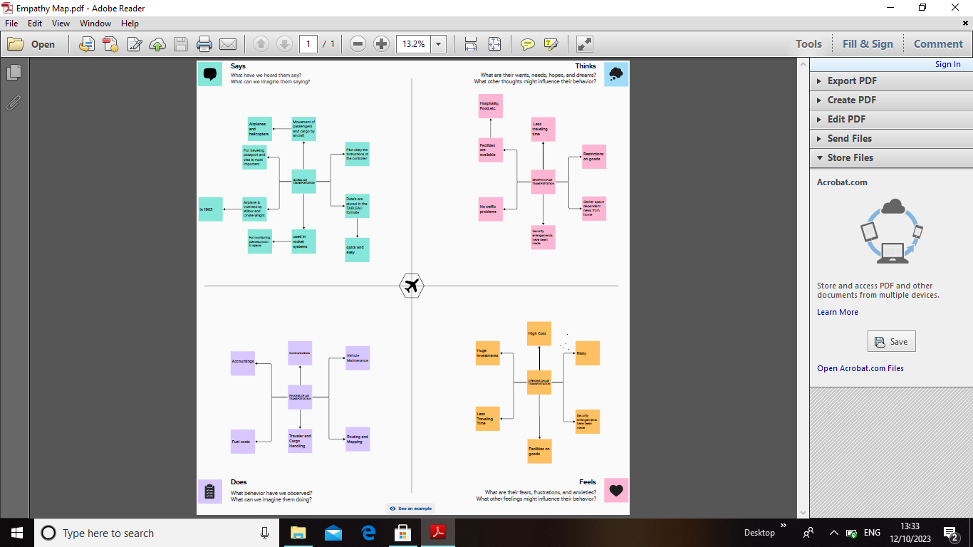

2.2 Ideation & Brainstorming Map3. RESULT

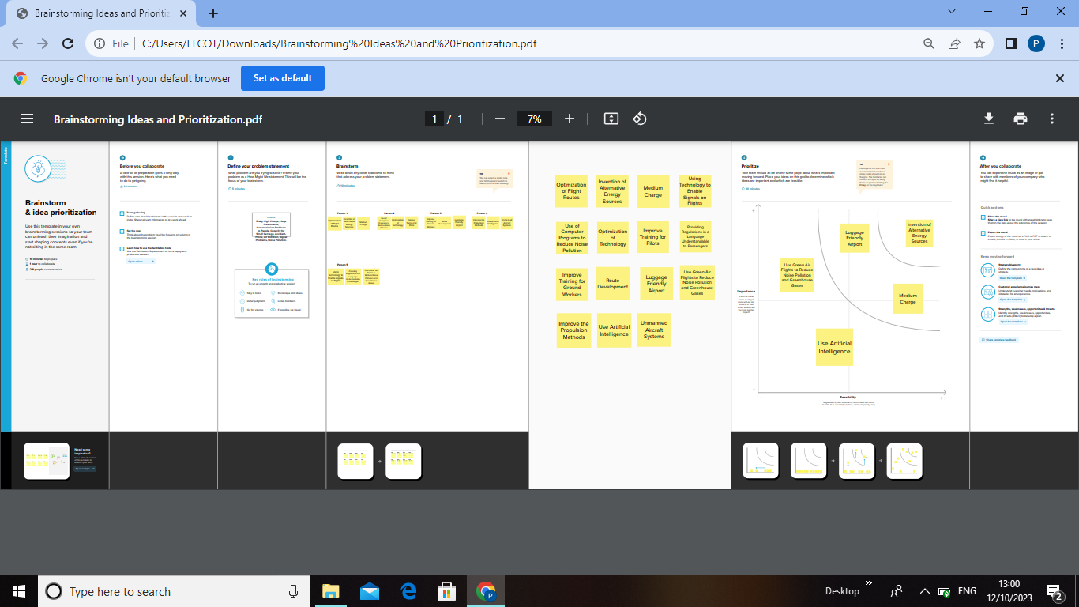

3. RESULT

Dashboard 1

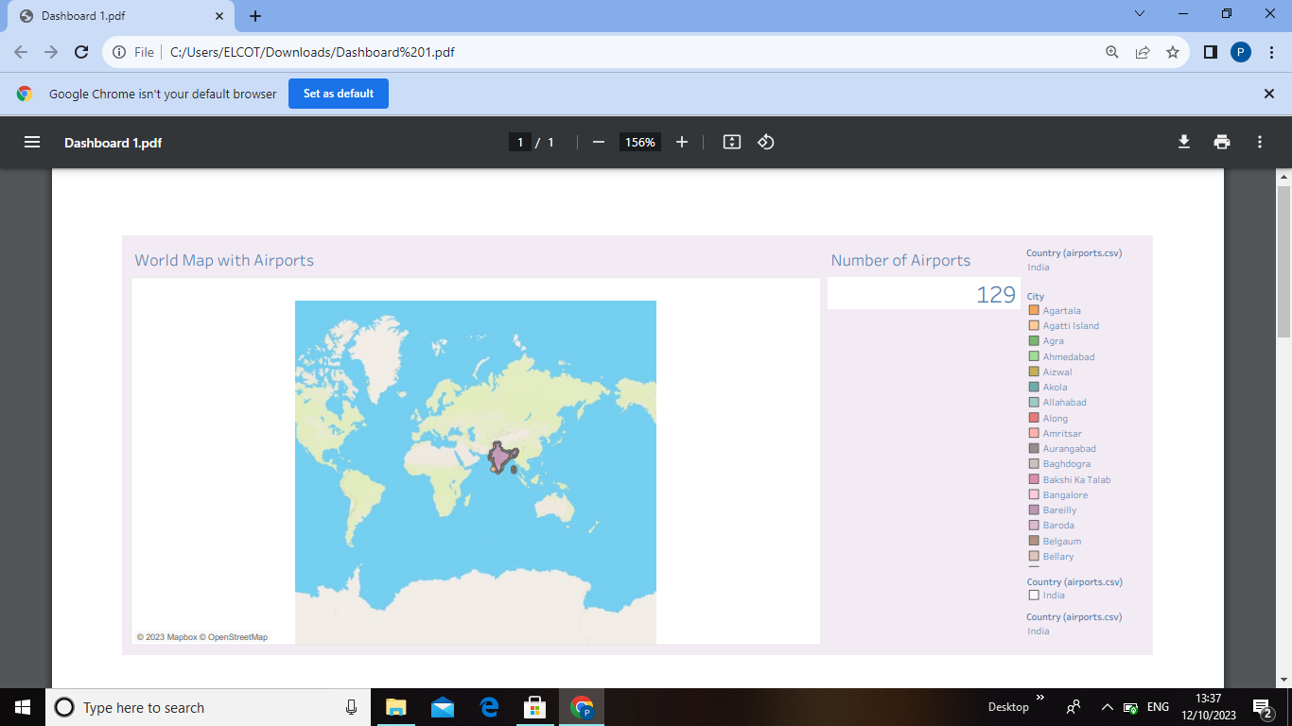

Dashboard 2

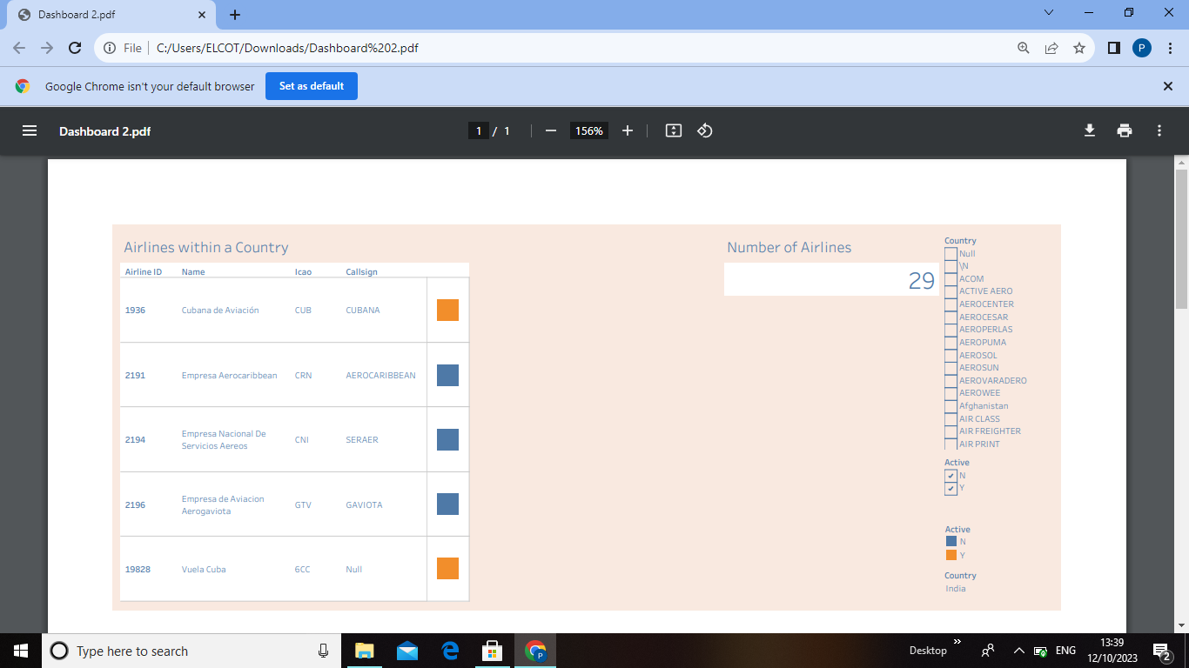

Dashboard 3

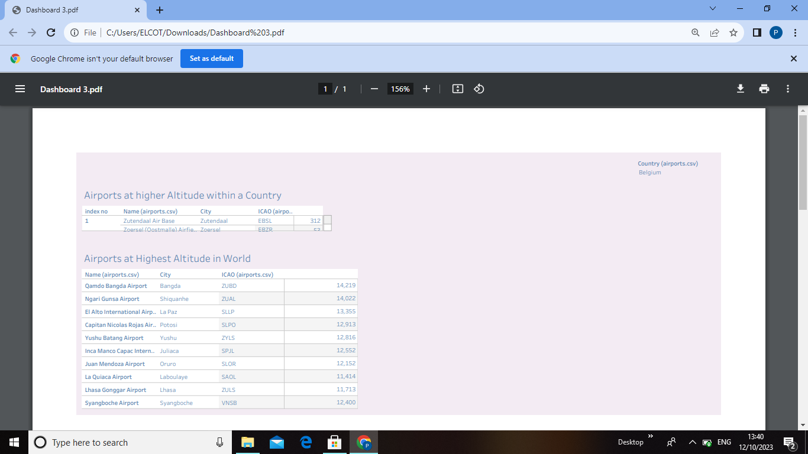

Dashboard 4

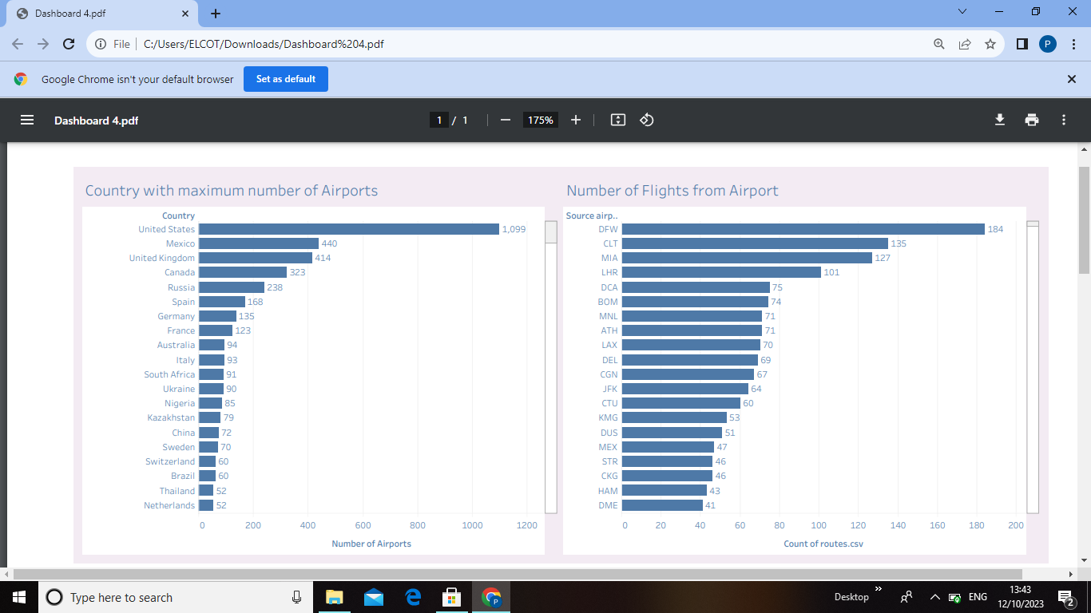

Story

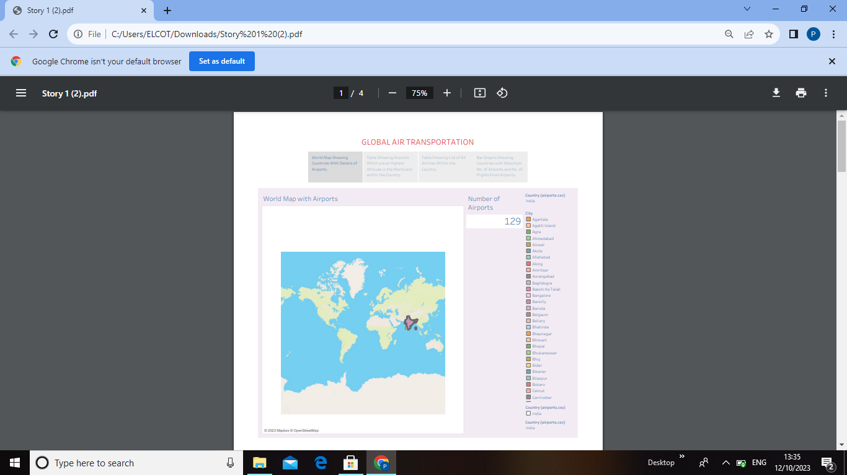

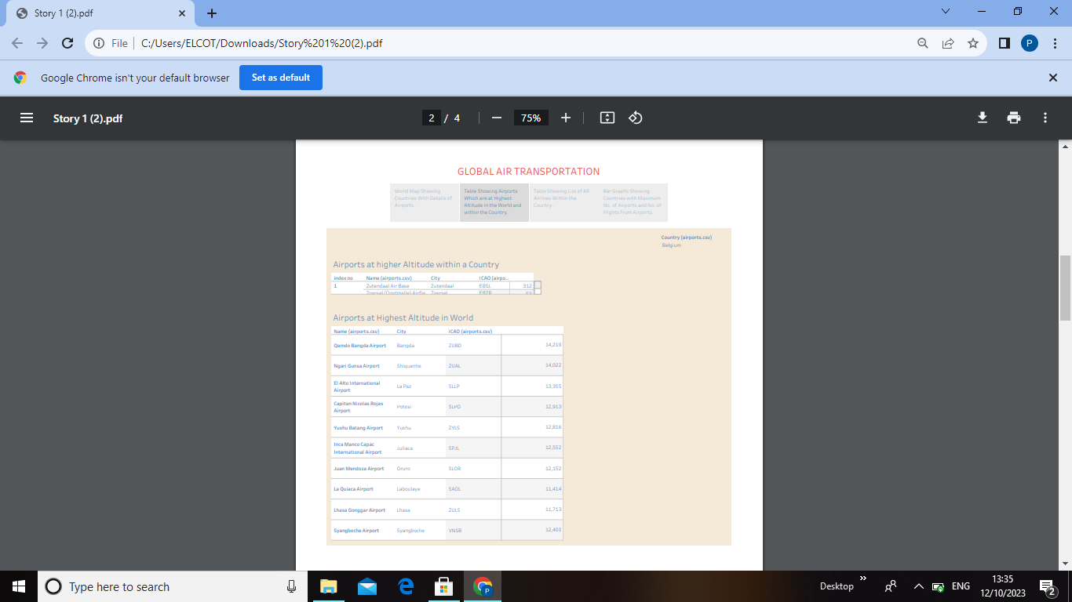

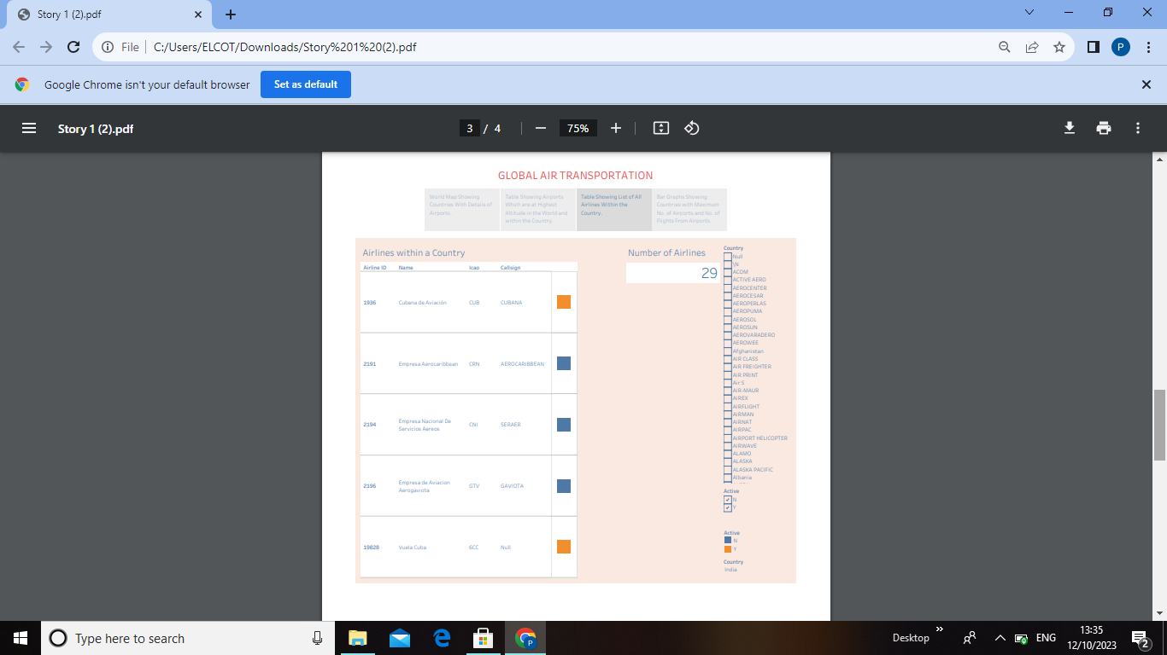

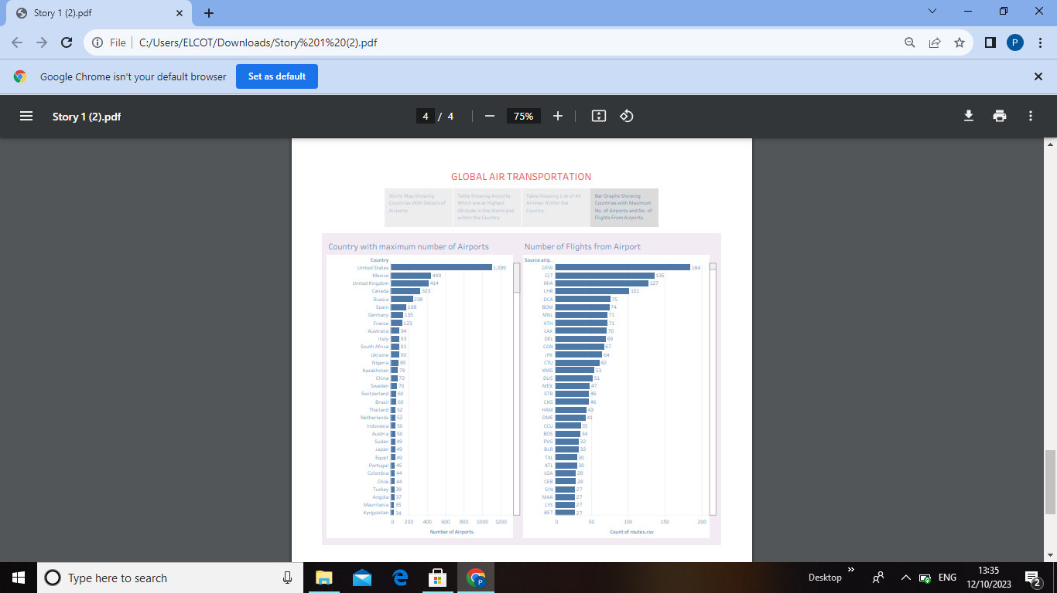

4. ADVANTAGES

*Fast Service

*Restrictions on Goods

*Security Arrangements have been made.

DISADVANTAGES

*Risky

*Huge Investments

*High Charge.

5. APPLICATIONS

*Aeronautical Engineering

*Satellite Communications

*Surveillance and Electronic Warfare.

6. CONCLUSION

The air transport industry is not only a vital engine of global socio-economic growth but is also of vital importance as a catalyst for economic development in most countries and for many regions within each country.

7. FUTURE SCOPE

Emerging technologies are reshaping with robotics, artificial intelligence, the Internet of things, unmanned aircraft systems and the push for hybrid and electric airplanes.